Pupil premium strategy statement – Sowe Valley Primary School

1. Summary information
School | Sowe Valley Primary School
Academic Year | 2020/21 | Total PP budget | £83,390 | Date of most recent PP Review | 2015
Total number of pupils | 210 | Number of pupils eligible for PP | 62 | Date for next internal review of this strategy | T.B.C

2. Current attainment (2018 data - 2019 data not available due to COVID19)
 | Pupils eligible for PP (your school) | Pupils not eligible for PP (national average)
% achieving in reading, writing and maths | 46% | 70%
% making progress in reading (asp) | -1.57 | 0.31
% making progress in writing (asp) | -2.06 | 0.24
% making progress in maths (asp) | -2.89 | 0.31

3. Barriers to future attainment (for pupils eligible for PP, including high ability)
In-school barriers (issues to be addressed in school, such as poor oral language skills)
A. | Limited language acquisition for PP children in reception– limited vocabulary along with limited letter recognition and reading skills upon entry to the EYFS stage. Autumn Baseline 11% ARE in Reading, 7% in writing, 21% in Speaking
B. | A high crossover of PP & SEND children with complex social, emotional and behavioural needs
C.
External barriers (issues which also require action outside school, such as low attendance rates)
D. | Poor attendance and punctuality for Pupil premium children
E. | Low socioeconomic demographic – IDSR school deprivation indicator Highest 20% (0.3)
F. | Poor parental support for parents in in reading and understanding how to support their children’s learning and support with Home Work.
4. Desired outcomes
A. | Gap with national is narrowed for EYFS outcomes for GLD
B. | Attendance for Pupil Premium Children improved
C. | Increase the number of PP pupils achieving progress in line with national

5. Planned expenditure
Academic year | 2020 - 2021
The three headings below enable schools to demonstrate how they are using the pupil premium to improve classroom pedagogy, provide targeted support and support whole school strategies.
1. Quality of teaching for all
Desired outcome | Chosen action / approach | What is the evidence and rationale for this choice? | How will you ensure it is implemented well? | Staff lead | When will you review implementation?
Increase the number of PP pupils achieving GLD in reading, writing and spoken communication, closing the gap on national standards and where necessary making accelerated progress. | Narrowing of vocabulary gap to have positive impact on reading and writing All pupils screened on entry for S and L deficit Welcomme Screening.  Intervention put in place. | Early speech and language intervention to narrow vocabulary gap on entry to school  Evidence and historic school data shows that children from disadvantaged backgrounds are affected by a poverty of vocabulary Nationally recognised PP vocabulary gap ( 30 million words by 4) | - SENCO + SENCO TA to screen children each term using Welcomme materials  - SENCO to meet with NLE termly  - Reception staff CPD – Time for Talk  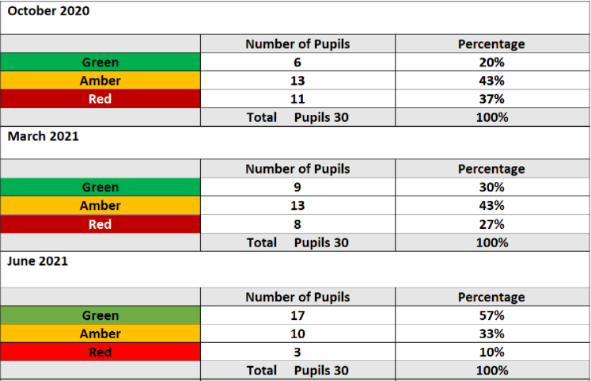 | Maria McDoanld | Termly review  COST  £100 screening materials  £2742  SENCO time allocation  Early intervention TA  £7680
Sub-total- £10,522
ii. Targeted support
Desired outcome | Chosen action/approach | What is the evidence and rationale for this choice? | How will you ensure it is implemented well? | Staff lead | When will you review implementation?
Increased attainment through focused intervention | Intervention – Pupil Premium Mentors years 1 – 6  JW will be leading intervention in Y2, 3 and 4 | Research has demonstrated that disadvantaged children do not receive support at home in terms of reading, learning spellings, learning tables or completing homework.  Each Pupil Premium child is allocated a mentor who works with the child individually each day to ensure that Pupil Premium children receive this support | Weekly reviews with PP mentors Tracking spelling/times tables and reading scores  Data due 5.7.21 – impact of Year 5 class split, interventions in Years 2, 3 and 4  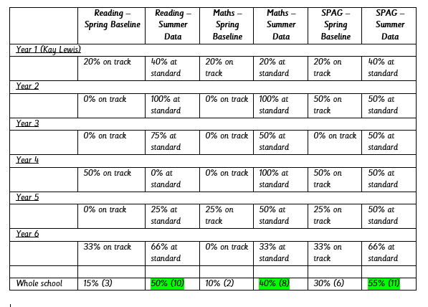  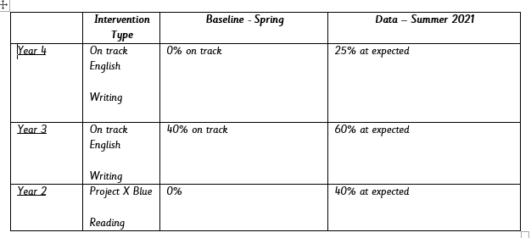 | Emma White | £26,484
Increased attainment through focused intervention | Year 6 - smaller class size during Spring Term  Year 5 – smaller class size end of Spring Term. | Overall, there is a relatively consistent finding that smaller classes are associated with slightly higher attainment when other factors are controlled for and when class sizes have been deliberately reduced in experimental evaluations. | Data tracking  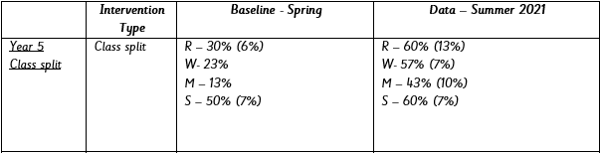 | Emma White  Jade Wakefield | £17400
Total budgeted cost |  |  |  |  | £43884
iii. Other approaches
Desired outcome | Chosen action/approach | What is the evidence and rationale for this choice? | How will you ensure it is implemented well? | Staff lead | When will you review implementation?
Increased attendance of PP children | Funding of Educational Welfare | Children who are persistently absent are affected in a number of ways. Primary-school children who have ongoing absence issues often come from disadvantaged backgrounds. These children may start school behind their peers in terms of their language and social development, and missing lots of school makes it harder for them to catch up. | Half termly meeting with Educational Welfare  Minutes of meetings Tracking of Pupil Premium Attendance  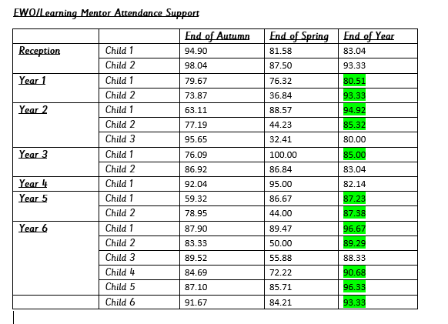 | CW  KL | COST £1500
Raised self-esteem and self-confidence, impacting on progress | Funding of learning mentor  New learning mentor joined the school at the start of the Spring Term. | Our learning mentor provide support and guidance to children who are experiencing difficulties in learning due to social, emotional or behavioural problems or other issues. Our learning mentor helps pupils overcome behavioural, social or emotional problems that are affecting their learning. | Discussions with Learning mentor Learning mentors notes Attendance figures  Data  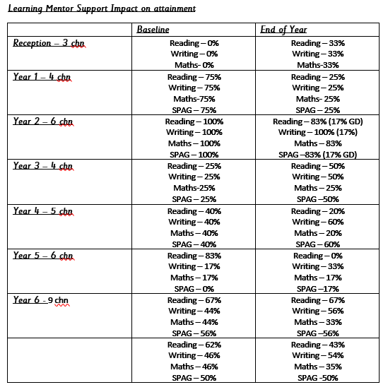 | CW | COST Learning mentor  £26,484
Provision and support in place for pupils – improved outcomes for pupils | Educational psychology  Hours from Spring Term will transfer to the Summer Term | EPs use their training in psychology and knowledge of child development to assess difficulties children may be having with their learning. They provide advice and training on how schools might help children to learn and develop. They recommend methods, or develop strategies in partnership with schools, to help a child learn more effectively. Strategies may include teaching approaches, improvements to learning environments, advice on curriculum materials and behaviour support. | EP reports Children’s targets  3 PP children have been assessed by our EP. One assessment was to support the submission of an EHCP. Two assessments are part of evidence needed for a further two EHCP requests.  (2 of these children are at high risk of exclusion so external advice was essential) | MM | £1000
Total budgeted cost |  |  |  |  | £28984
Total |  |  |  |  | £83390

