

FAQ’s

What is PA?
PA stands for ‘Persistently absent’. This is when your child’s attendance is below 90%

What is risk of PA?
Risk of PA is when your child’s attendance is at risk of dropping below 90% - we aim to offer early intervention support at this stage.

What is EPN?
EPN stands for ‘Education penalty notices’. EPN’s are issued for unauthorised absences, this includes term time holidays.

What if I just go on holiday and pay the fine?
EPN’s have now been capped nationally at 2 fines within any 3 year period. After this, other action, like a parenting order or prosecution has to be considered. This could mean a fine of up to £2500.

What is an un-authorised absence?
A child being kept off school un-necessarily or without good reason. Term time holidays is not a justified reason to take your child out of school.

What happens if I keep my child off and don’t contact the school?
School will call home to try and obtain a reason for absence. If no reason is provided, school may carry out a home visit – this is to check on the welfare of you and your child.

Sowe Valley Primary School
Attendance Team:

Head Teacher - Miss Emma White
School Business Manager – Mrs Heather Pilz
Learning Mentor – Miss Julie Lowe

Telephone: 02476 456063
Email: admin@sowevalley.coventry.sch.uk
Website: https://sowevalleyprimary.co.uk

*Please refer to the full attendance policy which can be found on our school website*

Our Mission

At Sowe Valley Primary School, we believe good attendance is vital for a child to achieve their full potential.

We aim to provide good attendance by providing a safe and motivating environment for all children.

As a team, we will, together break down any barriers that a child or family may have to accessing their education.

Every child matters, every day counts.

Parental home agreement

Parents/carers AND the school both have a legal duty for attendance. It is a legal requirement for each and every child to access regular education.

I need support with my child’s attendance

If you need support with your child’s attendance, please reach out to our learning mentor or inform your child’s class teacher.

School Attendance
Parent Guide
Absence Reporting

If your child is going to be absent from school, you must contact the school office before 9.00am to provide a reason for absence.
Medical Evidence

If your child is absent from school and is at risk of becoming persistently absent (at risk of falling below 90%) you will be required to provide medical evidence for your child’s absences.
This way, we can make sure absences are authorised.
Celebrating attendance

Celebrating our children’s attendance achievements is key to keeping our children motivated and engaged. We celebrate good attendance in so many ways such as…..
Weekly class prizes
Termly prizes
Half termly class prizes
Individual attendance recognition awards
Punctuality

If your child arrives to school after registration closes, your child will receive an unauthorised late mark. This affects your child’s attendance. You must accompany your child to sign in at the office when arriving late.
PA/risk of PA

We want to avoid children becoming ‘persistently absent’ (below 90%).
Interventions will be put in place when your child’s attendance becomes ‘at risk’ of becoming PA. This may include supportive parent meetings. Being persistently absent may make you liable for fines or school attendance referrals

Fines/Holidays

Holidays are in no circumstances authorised by school. Un-authorised absence due to holidays will result in a fine being issued from Coventry City Council.

Attendance Procedure

Every Day Counts

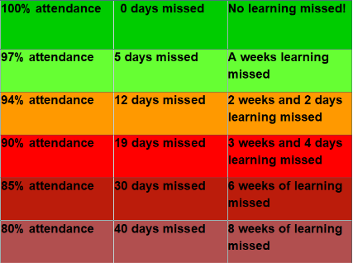
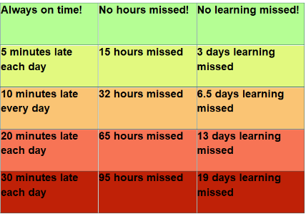
Every Minute Counts
‘90% attendance’ or ‘only 5 minutes late’ may sound like small issues, but the amount of learning missed is huge.
Make each day count!

